Mock database for Unit Tests
Scenario
You are tasked to write a unit test code for the below scenario.
The application in which you are teamed up with, deals with a network database in which your application stores the record or certain players. It involves storing and retrieval of player details. Your role is to write unit testing the player module which involves an external dependency. You can’t proceed with unit testing.
After investigating the problem scenario, you found a solution and that is creating mock objects of these external dependencies in the unit testing project so that you can achieve speedier test execution and loose coupling of code.
Task1
In this task, you will create a class library that will be used for unit testing.
- Create a Class Library (Language C#) project using Visual Studio IDE, and name it as PlayersManagerLib.
- Rename the default Class1 class name as PlayerManager.
- Include the following namespaces with ‘using’ directive.
  - System.Data
  - System.Data.SqlClient
  - Define an interface

Task2
In this task, you will create unit test project which make use of NUnit framework and Moq.
- Create a new class library project called PlayerManager.Tests and add the following external dependencies to it using NuGet Package Manager.
  - NUnit
  - NUnit Test Adapter
  - Moq
- Add the references of assemblies as appropriate including PlayersManagerLib.
- Write unit test code and mock the PlayerMapper (IPlayerMapper) class.
- Use TestFixture, OneTimeSetUp and TestCase attribute classes on top of test class, init method and test method respectively.
- Use ExpectedException attribute to specify that the execution of a test will throw an exception.
- When the RegisterNewPlayer function calls IsPlayerNameExistsInDb, you need to make sure that the mock object to return “false”.
- In the test method, assert various player attributes.

Aim
To perform unit testing of the Player module using NUnit and Moq by mocking database interactions and avoiding direct access to the SQL Server database.

Project Structure
PlayersManagerLib
── IPlayerMapper.cs
── PlayerMapper.cs
── Player.cs
── PlayersManagerLib.csproj
PlayerManager.Tests
── PlayerTests.cs
── PlayerManager.Tests.csproj

Required NuGet Packages
- NUnit
- NUnit3TestAdapter
- Moq
- Microsoft.NET.Test.Sdk
- System.Data.SqlClient

Interface: IPlayerMapper
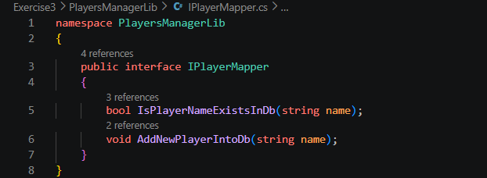

Class: PlayerMapper
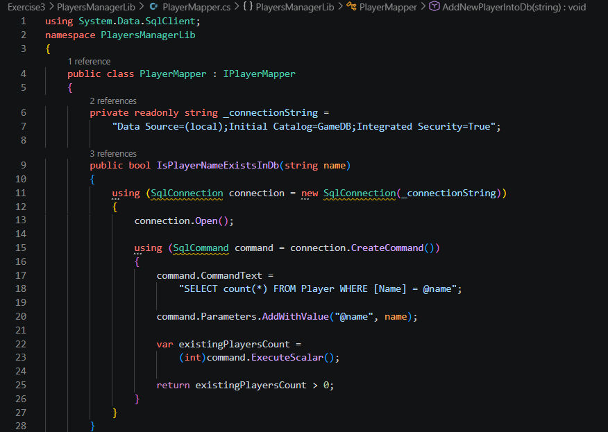
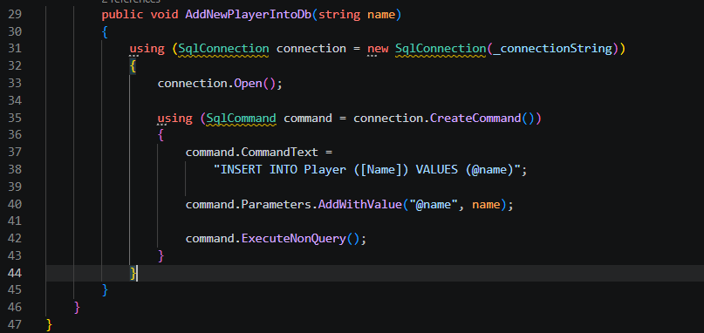
Class: Player
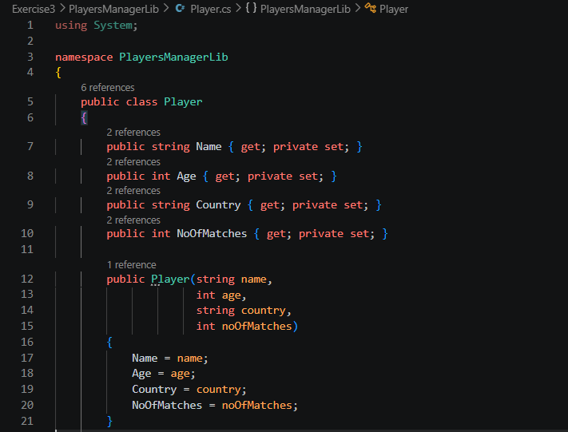
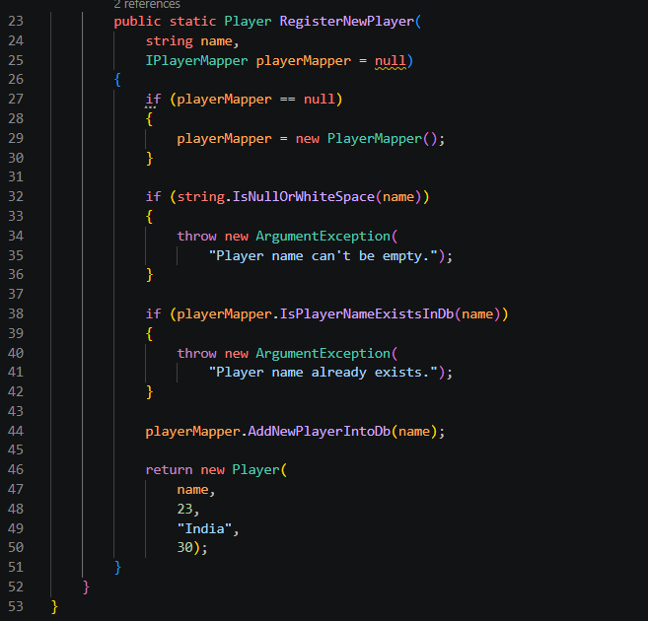
Unit Test Class(PlayerTests.cs)
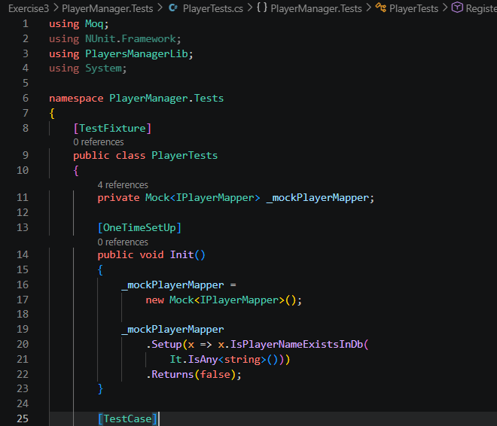
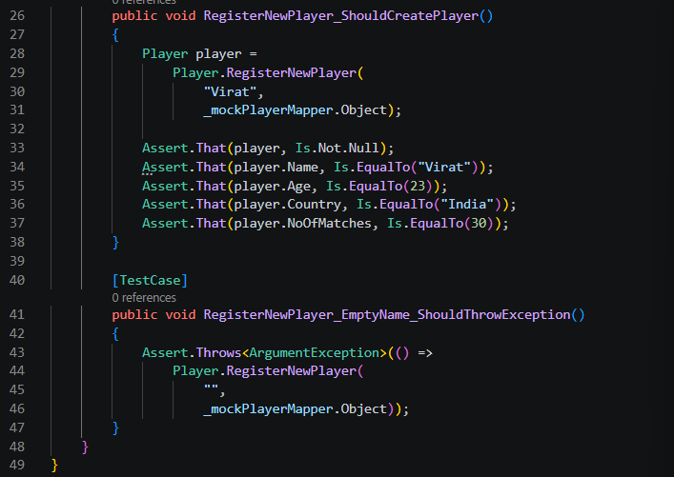

Test Execution Output
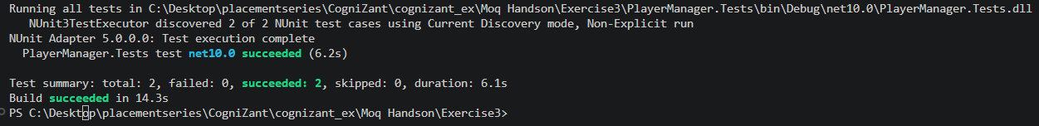

Conclusion
- Successfully mocked database access using Moq.
- Performed unit testing without connecting to a real database.
- Verified player registration functionality and exception handling.
- All test cases executed successfully.

